dir(), __dict__ and help() methods in python
We must look into dir(), __dict__() and help() attribute/methods in python. They make it easy for us to understand how classes resolve various functions and executes code. In Python, there are three built-in functions that are commonly used to get information about objects: dir(), dict, and help(). Let's take a look at each of them:
The dir() method
dir(): The dir() function returns a list of all the attributes and methods (including dunder methods) available for an object. It is a useful tool for discovering what you can do with an object. Example:
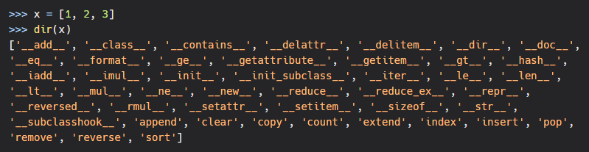The __dict__ attribute
__dict__: The __dict__ attribute returns a dictionary representation of an object's attributes. It is a useful tool for introspection. Example:
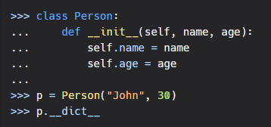
Output
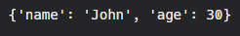

The help() mehthod
help(): The help() function is used to get help documentation for an object, including a description of its attributes and methods. Example:
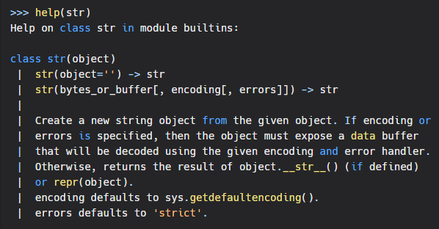In conclusion, dir(), dict, and help() are useful built-in functions in Python that can be used to get information about objects. They are valuable tools for introspection and discovery.

